The Anglican Women’s Studies Council
Invites you to the

Book Launch
of our latest publication

KA TUITUIA TATOU E TE AHO TAPU
The Sacred Thread That Weaves Us Together

Sunday, 2nd December 2018
from 2pm – 5pm

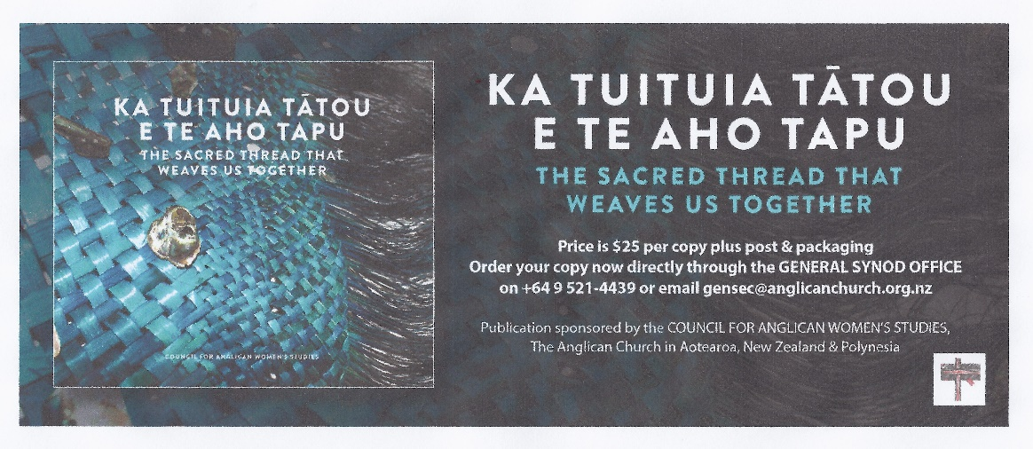
St Matthews Church, Waipatu
Followed by refreshments at Tamatea Clubrooms (next door on Marae)
Some of the artwork featured in the book will be on display

Please RSVP to Karena de Pont on anglicanwomenstudies@gmail.com

